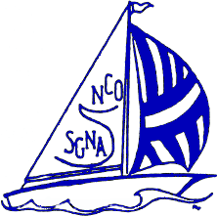

*Registration Form*

North Coast Ohio SGNA

Winter Education Program

Saturday November 16, 2024

7:30 a.m. – 1:00 p.m.

AhujaMedical Center Rosenberg Conference Center

399 Richmond Road

Registration:

__ $40 RN/LPN SGNA member

__ $50 RN/LPN Non-Member

__ $10 GI Technician

***SPACE IS LIMITED TO 40 ATTENDEES SO PLEASE REGISTER EARLY***

**Registration must be postmarked by** ***October 28th, 2024***. **Must include SGNA Member Number for the discounted rate. Registration fee is non-refundable**

Name __________________________________ RN ___ LPN ___ GI Tech ___

SGNA Member Y / N Member # _____________ Certified (CGRN) Y / N

Address ___________________________________________________________

Phone # ______________________ Home Email __________________________

Employer __________________________________________________________

**Mail this form and check made payable to NCOSGNA to:**

Sean Dille

5404 Marshview Lane

Mentor Ohio 44060

Questions;Sean Dille [seandille27@gmail.com](mailto:seandille27@gmail.com)

440-463-3938